Replication of the Gekkotan Phylogenetic Tree

Elizabeth Glynne B.

28 April 2019

**Introduction**

A big component of science lies in repeatability. One of the things discussed in class is how the various parameters of the analyses used can influence the resulting trees, either in branch lengths or resulting topologies. Though, when the proper methods are used, often the differing methods will result in the same or relatively comparable answers.

As an evolutionary morphologist, I rely on molecular phylogenies created by other scientists to run my analyses regarding morphological character evolution. I do not create phylogenies based on morphology as the selection of characters can be subjective and far fewer in character numbers compared to the sequences used. Because of this limitation in the data that I use, it is important for me to be able to understand how the molecular phylogeny is created and why certain parameters were selected compared to others.

There are two main molecular phylogenies that are currently used for geckos: one created on a broad scale incorporating as many taxa within Squamata as possible (Pyron et al., 2013) and another that uses just Gekkotan phylogeny with a limited number of species (Gamble et al.,2015). Dr. Pyron’s work has come under scrutiny for missing data in his analyses, which is why individuals who work with geckos will gravitate towards the use of Dr. Gamble’s phylogeny. Thus, my future work with morphological data will be using the phylogeny from Gamble et al.’s 2015 publication, particularly for evaluating character state evolution (Figure 1). As I will be relying on this phylogeny for future studies, I want to try and replicate their analysis in an attempt to understand the choices made for the methods and to have an opportunity to use the new methods to try and compare my results against a published phylogeny. I will be looking specifically into if the use of different tree-building methods would have affected the resulting topology. I plan to replicate Gamble et al.’s Bayesian analysis using MrBayes, compared to BEAST, and to also perform a likelihood and parsimony analyses. Given that I will be using the same data and the same or comparable parameters, I predict that the three different analyses (Bayesian Inference, Maximum likelihood, and Maximum Parsimony) will ultimately yield different topological results, with the differences increasing between the published phylogeny, respectively speaking.

**Methods**

*Data and General Parameters.* The aligned sequences from the publication was download from the listed dryad repository (Gamble et al. 2015). The data file included the 5 nuclear coding genes (RAG1 (1074 bp), RAG2 (366 bp), C-MOS (284 bp), ACM4 (477 bp), PDC (397 bp)), one mitochondrial fragment (protein coding ND2 gene), and the associated tRNAs (1414 bp)) from the 280 taxa used in the study (including 264 gecko species and 16 outgroups). As noted in the original publication, alignment details were found in the previous Gamble et al. 2008 publication, where the data was identified as being aligned using T-Coffee (Notredame et al. 2000). For the purpose of each analysis in this study then, Gallus (the chicken), was identified as the primary outgroup taxa.

I relied on the partition schemes found within the published study for the use of this replication attempt. This included a BIC partition scheme as determined from PartitionFinder v1.0.1 (Lanfear et al. 2012). There were three partitions identified, including: all nuclear gene data, first and second codon positions of the mtDNA dataset plus tRNAs, and third codon positions of the mtDNA dataset plus tRNAs. I also used the same model of sequence evolution, GTR+G, as determined from PartitionFinder in the publication.

*Bayesian Inference.* The original analysis was done using BEAST 1.0.1 (Bayesian Evolutionary Analysis Sampling Trees). I used MrBayes, in an attempt to see how the results would compare with the original BEAST analysis (Huelsenbeck, 2001). Using the previously stated partitions, the partitioned analysis ran 4 chains for 1 million generations and printed the sample and diagnosing frequencies every 2,500 iterations. Upon completion, a stepping stone analysis was conducted. The stepping stone ran for 1 million generations and printed the diagnostic frequency every 2,500 iterations. Summaries were then completed for both the parameter and the tree files, with the consensus tree being retained. Summary files were viewed using Tracer v1.7.1 (Rabaut et al. 2018).The consensus tree file was then viewed using FigTree v.1.4.4 (Rambaut, 2012) and compared directly to the original publication’s tree using Dendroscope v3.5.10 (Huson et al. 2018).

*Maximum Likelihood.* The maximum likelihood analysis was completed using RAxML-NG v.0.6.0 (Koslov et al. 2018). Due to size of the dataset and software compatibility issues, the RAxML-NG web service, address: https://raxml-ng.vital-it.ch/#/, was utilized. The data file was converted from the nexus format to a FASTA format using an online resource available through the Hepatitis C Virus Database Project: https://hcv.lanl.gov/content/sequence/FORMAT_CONVERSION/form.html. The FASTA file was then uploaded into the RAxML-NG online form, where the first analysis was ran with the default settings (10 starting trees for parsimony and likelihood, unpartitioned using the GTR+G model, and optimizing topology, branch lengths and model). Once the analysis was successfully run, a more extensive analysis was conducted, using 100 starting parsimony trees and 1000 likelihood trees, with a 0.05 bootstrapping cutoff). After two weeks, the results of the analysis were sent to my email address and analyzed. The final files were viewed using a text editor and FigTree V.1.4.4 (Rambaut, 2012). The consensus tree file was then compared directly to the original publication’s tree using Dendroscope v3.5.10 (Huson et al. 2018).

*Parsimony.* The parsimony analysis was completed using TnT (Tree Analysis using New Technology, Giribet 2005). The nexus data file was converted to a .*tnt* file using Mesquite v.3.6 (Madison & Madison, 2018). A preliminary search running 10 trees using various combinations of the new technology search parameters was conducted to evaluate which of the configurations of the searching methods would result in the most parsimonious tree. This was done to run preliminary tests to see which methods would achieve the most parsimonious scores using the least restrictive, computationally intensive methods, prior to running the exhaustive searches. After running different searches using various parameters, three sets of parameters obtained the same most parsimonious score of 803,339: 1) search and tree fusing, 2) ratchet and tree fusing, and 3) search, tree fusing, ratchet and drift (all of the parameters). The more exhaustive search for the analysis was then conducted using the default setting of the sectorial search (both random and consensus) and tree-fusing. The search used a random seed and ran 10,000 trees to find the most parsimonious score a single time. The number of tree space searched was limited as my personal computer did not have the RAM to run the million trees. All trees were retained after the search where a consensus tree was built and saved both with and without branch lengths.

**Results**

*Bayesian Inference.* In the analysis conducted here the estimated mean marginal likelihood of the partitioned model was -302,962.After the stepping-stone sampling, the estimated marginal likelihood of the partitioned model was -302,881. The analysis recovered a paraphyletic relationship of Gekkota, and properly recovered the seven families in Gekkota, with the proper outgroup relationships (Figure 2). In the first group of Gekkota, Carphodactylidae and Pygopodidae were found to form a clade with Diplodactylidae. In the second group of Gekkota, Eublepharidae was found to be the sister group to the Phyllodactylidae + Gekkonidae + Sphaerodactylidae clade. Monophyletic relationships were found in Carphodactylidae and Pygopodidae, whereas paraphyletic relationships were found within the remaining families. There were no genus level discrepancies with Carphodactylidae or Eublepharidae compared to the original phylogeny, but the other families did have discrepancies in the genus level relationships (Figures 5 – 11).

*Maximum Likelihood.* After the bootstrap analysis, the estimated marginal likelihood of the partitioned model was -302,611. As was found from both the original and new Bayesian analyses, a paraphyletic relationship of Gekkotans was recovered. Additionally, the seven families were also recovered in the same topological placement as the original publication and the Bayesian analysis (Figure 3). Monophyletic relationships were again only found within the Carphodactylidae and Pygopodidae families. Paraphyletic relationships were found within the remaining five families. Genus level comparisons were all different for each family, except the Eublepharidae family (Figures 5-11).

*Parsimony.* A total of 24 trees were retained with the maximum parsimony score of 803,339. A consensus tree was completed upon running the bootstrap analysis with the same new technology search parameters as listed above. The seven families were recovered in the parsimony analysis, however the topological arrangement varied compared to the other analysis (Figure 4). Instead of recovering a clade with Diplodactylidae as sister group to Pygopodide + Carphodactylidae, a clade with Pygopodidae sister to Diplodactylidae + Carphodactylidae was found. The remaining topological relationships at the family level were consistent with the original publications results. Just as with the likelihood analysis, the only genus level relationships successfully recovered were that in the Eublepharid family (Figures 5-11).

**Discussion**

*General.* Overall an exact replication of the original phylogeny was not recovered (Figures 1 – 4). This may have been due to the lack of additional characters included in the original publication, by not using the time component as done in the original publication, a limited generation time, or additional human errors, as I am new to this process. In looking at the differences, the original publications (Gamble et al. 2008 and 2015) looked at character traits (digit morphology or diurnality) in addition to the construction of the phylogenies. As a result, the log likelihood scores from the construction of the phylogeny were not included in the publications, nor were the files available in the repositories. Therefore, no accurate comparisons could be made to the original published pylogeny, but, interestingly, the maximum likelihood score resulting from RAxML was lower than the likelihood from the MrBayes analysis. Additionally, in comparison of the topologies on a family level, the only analysis that varied was the parsimony analysis. Pygopodidae was pulled out of the clade with Carphodactylidae and placed separately, forming a clade between Carphodactylidae and Diplodactylidae. Though this analysis is done with molecular data, that is interesting as the Pygopods are the limbless geckos and this was the topology that was supported by morphology for a long time prior to an advance in the methodologies. I think that this separation happened because the parsimony methods did not allow for partitioning of the data, at least not to my knowledge. On a genera level, there were many varying results. Surprisingly, the family Eublepharidae was correct at a genus level for all three analysis and the Carphodactylids were correct for the likelihood and Bayesian analyses. This could be because of the limited number of taxa within the groups compared to the other families. Gekkonidae in all three analyses resulting in errors, with the least amount in Bayesian and the most in parsimony methods. Again, this is not too surprising as Gekkonidae is known to be less resolved throughout gekkotan systematics.

*Comparison of methods.* Overall, this study has made it apparent as to how the parameter and analysis selection can strongly influence the resulting inferences. Just in trying to replicate a published phylogeny, the replication was altered based on variations from the original parameters used. There are many reasons as to why an exact replication was not found, but I think it is important to note that with 280 taxa the tree space search is huge. My computer was limited to the amount of run time that could have occurred and was ultimately a fraction of the publication’s original 20 million runs. Additionally, this also brings to light the importance of replication as a whole with these complicated procedures. It would be nice if a publication of script would be required so that the process is easily replicated. However, I am not sure how feasible it is to require that as it can be challenging to have a single script for the various programs used to just conduct one analysis.

***References***

Gamble T, Greenbaum E, Jackman TR, and Bauer AM. (2015). Data from: Into the light: diurnality has evolved multiple times in geckos. Dryad Digital Repository. doi:10.5061/dryad.97b50.

Gamble T, Greenbaum E, Jackman TR, Bauer AM (2015) Data from: Into the light: diurnality has evolved multiple times in geckos. Dryad Digital Repository. <https://doi.org/10.5061/dryad.97b50>

Gamble, T., Bauer, A. M., Greenbaum, E., & Jackman, T. R. (2008). Out of the blue: a novel, trans‐Atlantic clade of geckos (Gekkota, Squamata). Zoologica Scripta, 37(4), 355-366.

Gamble, T., Greenbaum, E., Jackman, T. R., & Bauer, A. M. (2015). Into the light: diurnality has evolved multiple times in geckos. Biological Journal of the Linnean Society, 115(4), 896-910.

Giribet, Gonzalo. "TNT: tree analysis using new technology." (2005): 176-178.

Huelsenbeck, J. P., and Ronquist, F. (2001). MRBAYES: Bayesian inference of phylogenetic trees. Bioinformatics, 17(8), 754-755.

Huson D. H. & C. Scornavacca. Dendroscope 3: An interactive tool for rooted phylogenetic trees and networks, Systematic Biology (2012), http://sysbio.oxfordjournals.org/cgi/content/abstract/sys062?ijkey=ZCxPRbYt74aQJhR&keytype=ref, software freely available from www.dendroscope.org.

Huson D. H., D.C Richter, C. Rausch, T. Dezulian, M. Franz and R. Rupp.( 2018). Dendroscope: An interactive viewer for large phylogenetic trees, BMC *Bioinformatics*. 8(1):460

Kozlov, A. M., Darriba, D., Flouri T., Morel, B., & A. Stamatakis. (2018). RAxML-NG: A fast, scalable, and user-friendly tool for maximum likelihood phylogenetic inference. bioRxiv. doi:10.1101/447110

Kozlov, A. M., Darriba, D., Flouri, T., Morel, B., and Stamatakis A. (2018). RAxML-NG: A fast, scalable, and user-friendly tool for maximum likelihood phylogenetic inference. bioRxiv. doi:10.1101/447110

Lanfear, R., Calcott, B., Ho, S. Y., & Guindon, S. (2012). PartitionFinder: combined selection of partitioning schemes and substitution models for phylogenetic analyses. Molecular biology and evolution, 29(6), 1695-1701.

Maddison, W. P., & D. R. Maddison. (2018). Mesquite: a modular system for evolutionary analysis.Version 3.6 <http://mesquiteproject.org>

Notredame, C., Higgins, D. G. & Heringa, J. (2000). T-Coffee: a novel method for fast and accurate multiple sequence alignment. Journal of Molecular Biology, 302, 205–217.

Rambaut, A. (2012). FigTree v1. 4.

Rambaut, A., Drummond, A. J., Xie, D., Baele, G., & Suchard, M. A. (2018). Posterior summarization in Bayesian phylogenetics using Tracer 1.7. Systematic biology, 67(5), 901-904.

Silvestro, M. (2012). raxmlGUI: a graphical front-end for RAxML. *Organisms, Diversity, and Evolution*. 12:335-337. DOI: 10.1007/s13127-011-0056-0

***Figures***

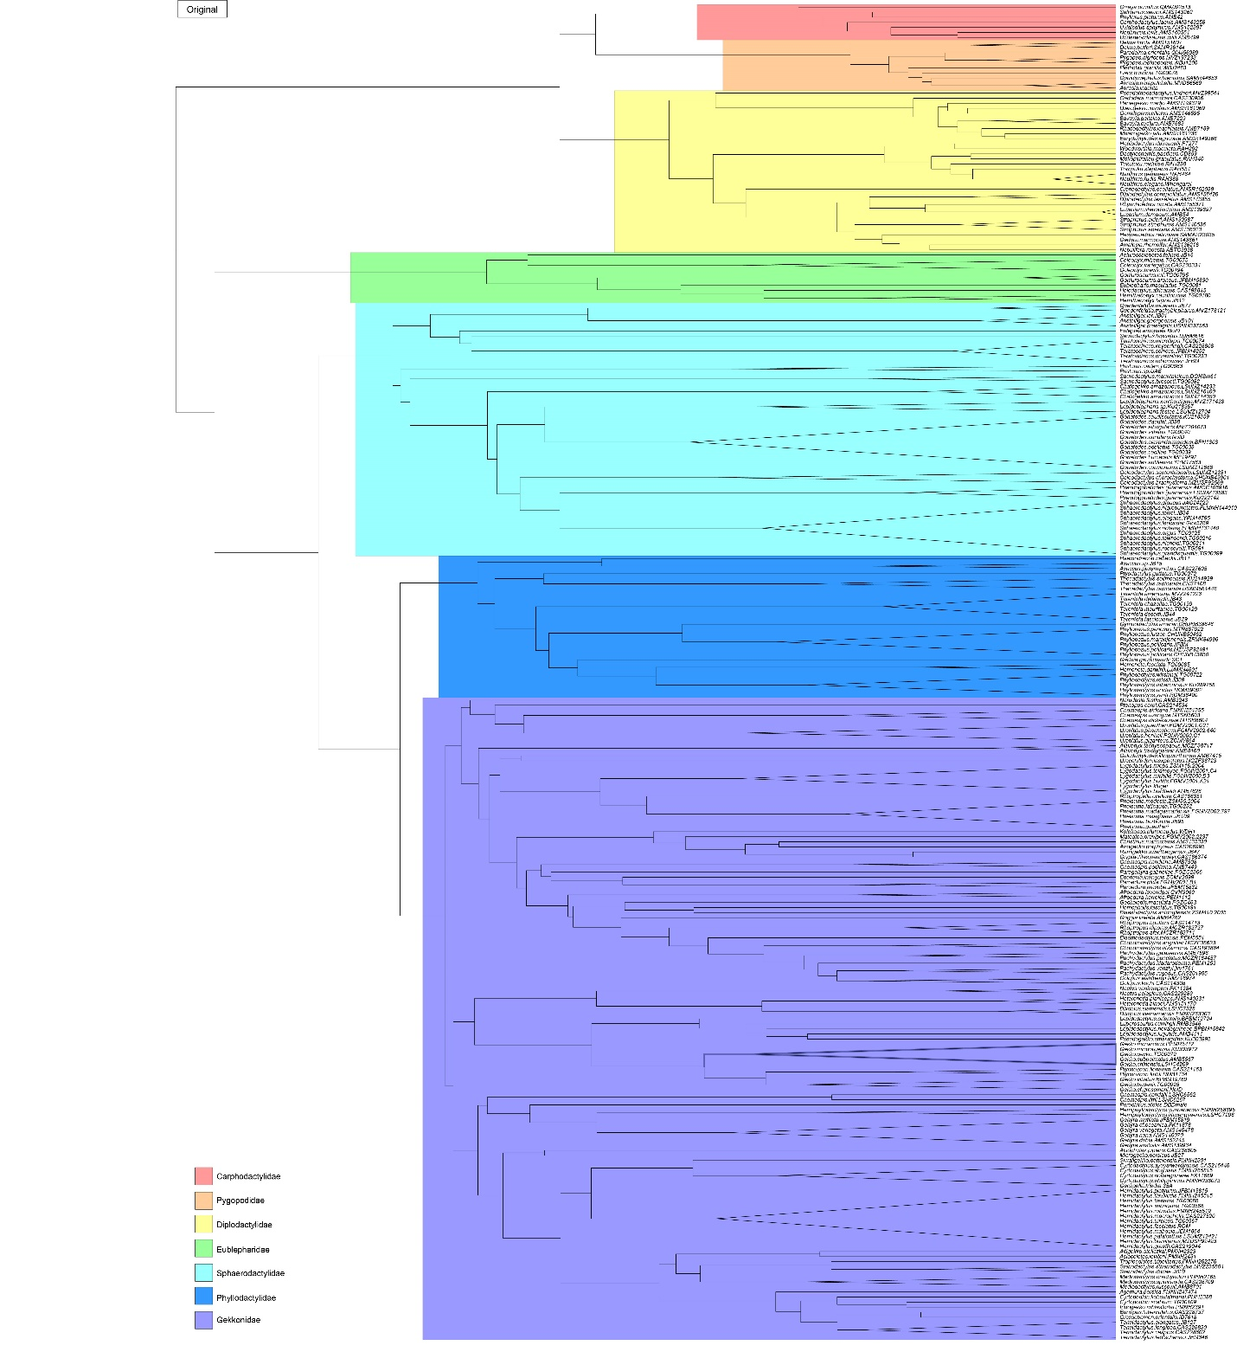

Figure 1. Tree from the original Bayesian analysis done in Gamble et a. 2015. Each color coordinates to a family within the infraorder Gekkota. Outgroups have been removed for viewing of figure, with the taxa collapsed to the genus level.

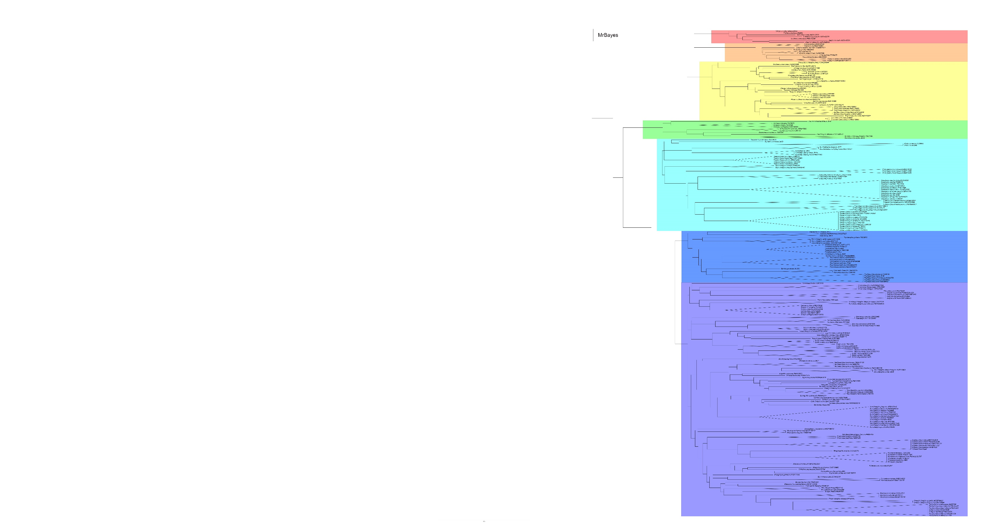

Figure 2. Tree from the Bayesian inference analysis. Each color coordinates to a family within the infraorder Gekkota. Outgroups have been removed for viewing of figure, with the taxa collapsed to the genus level.

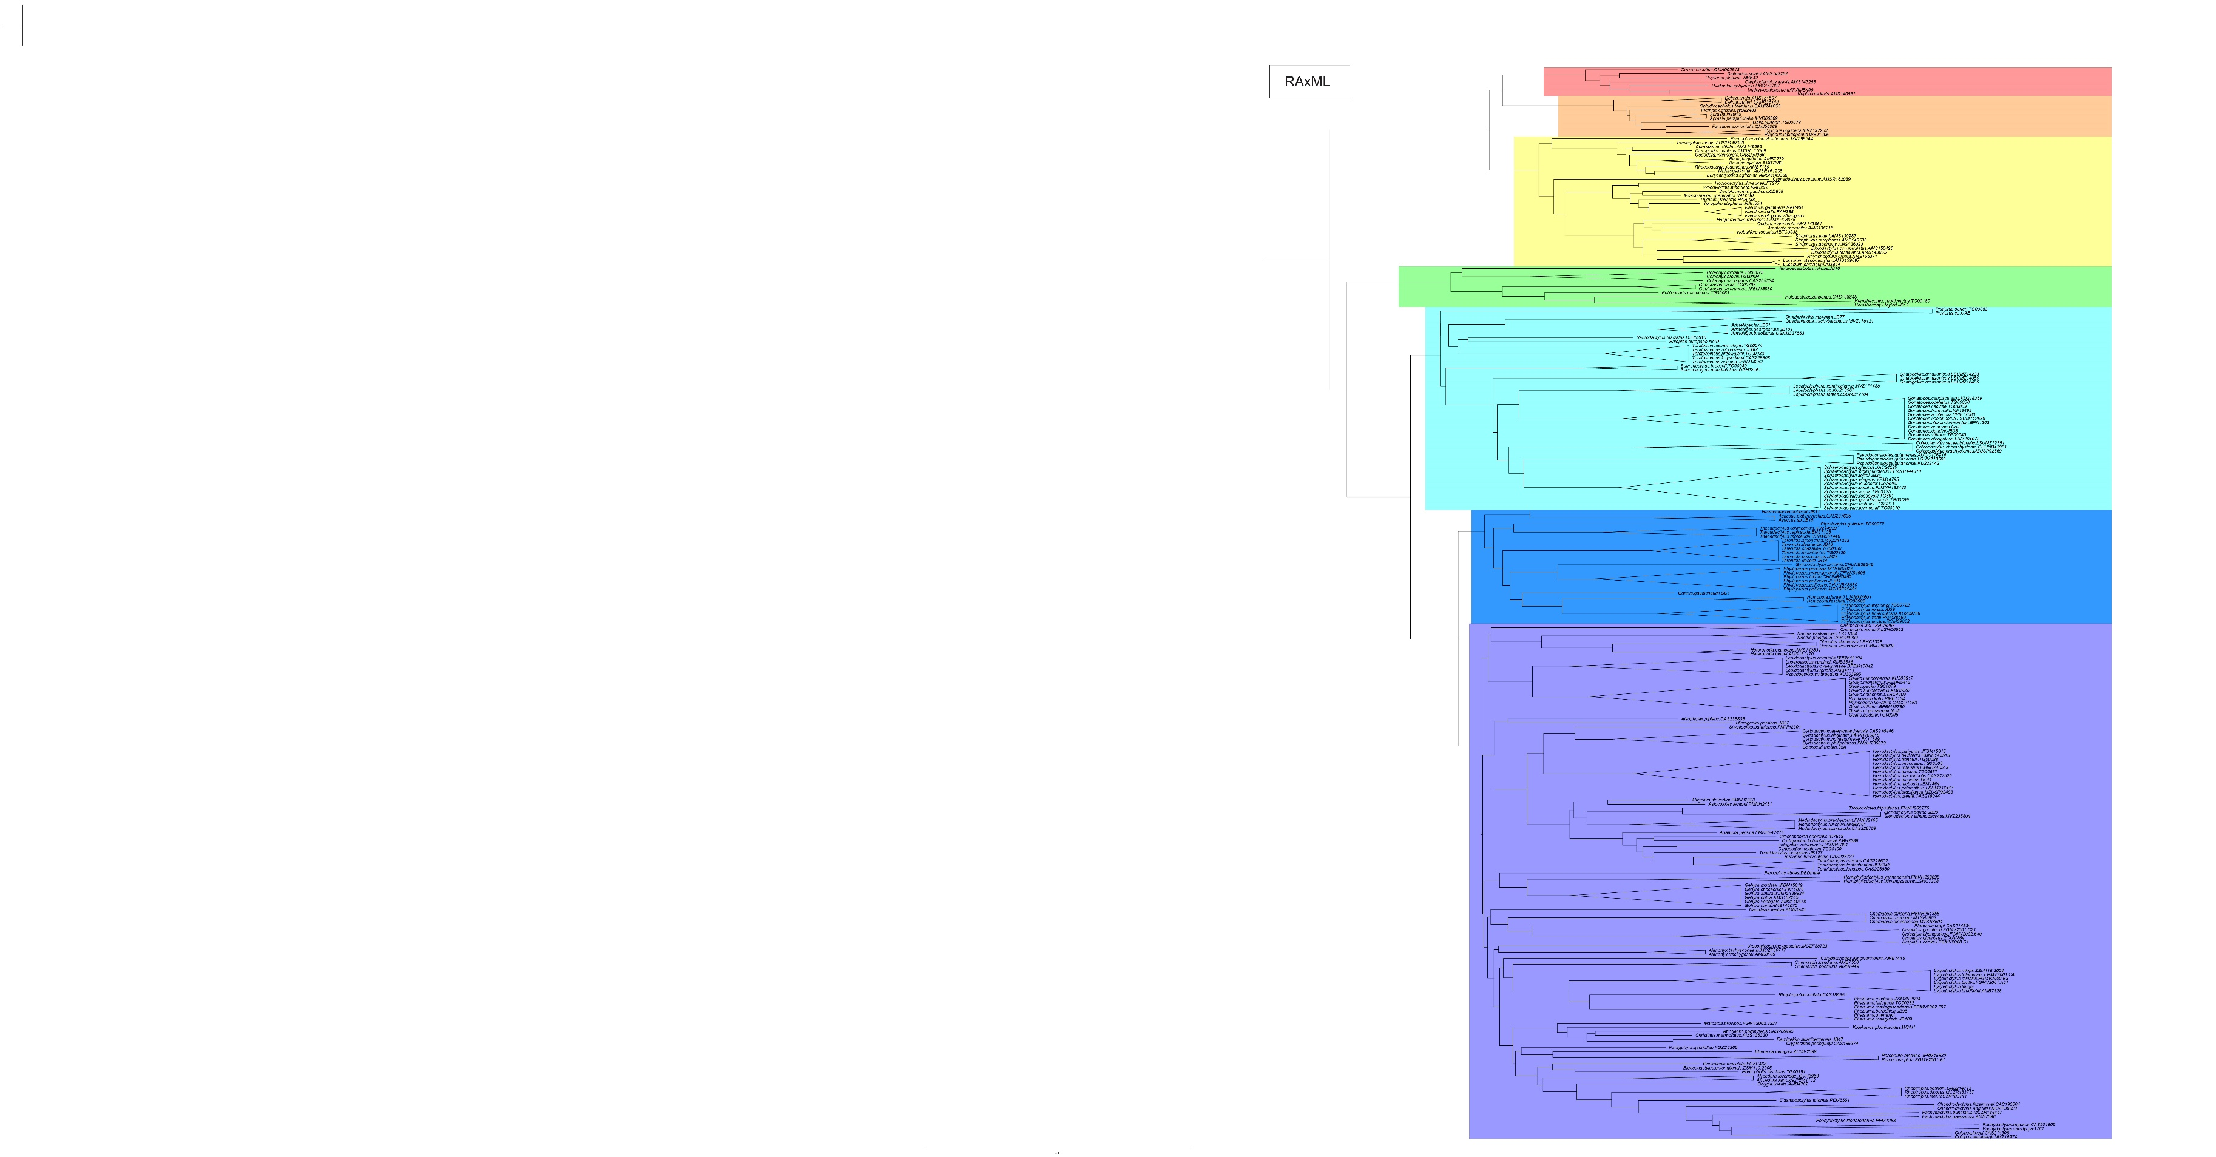

Figure 3. Consensus tree from the maximum likelihood analysis. Each color coordinates to a family within the infraorder Gekkota. Outgroups have been removed for viewing of figure, with the taxa collapsed to the genus level.

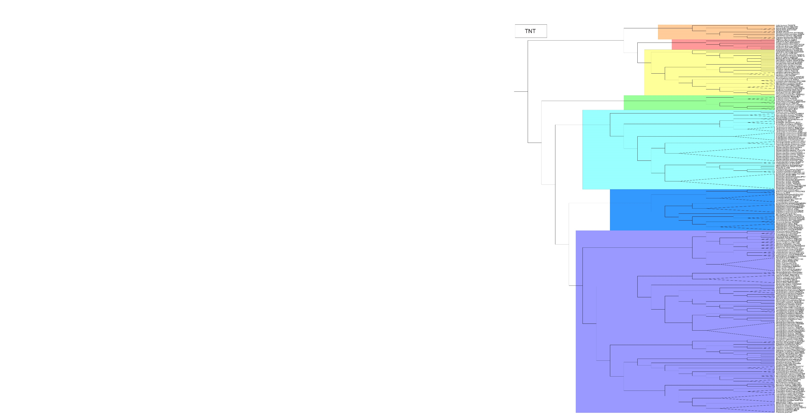

Figure 4. Consensus tree from the maximum parsimony analysis. Each color coordinates to a family within the infraorder Gekkota. Outgroups have been removed for viewing of figure, with the taxa collapsed to the genus level.

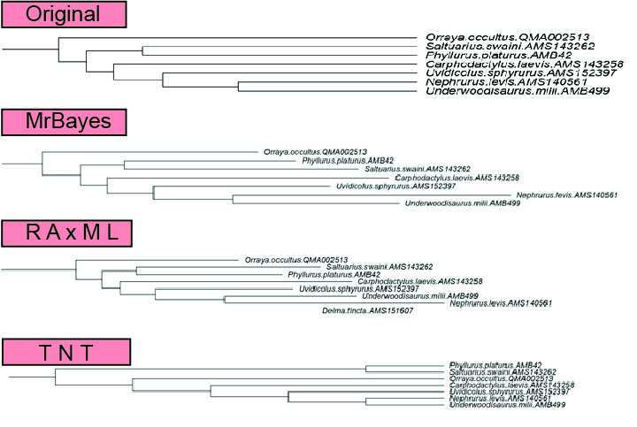

Figure 5. Comparison of the four topologies of Carphodactylidae.

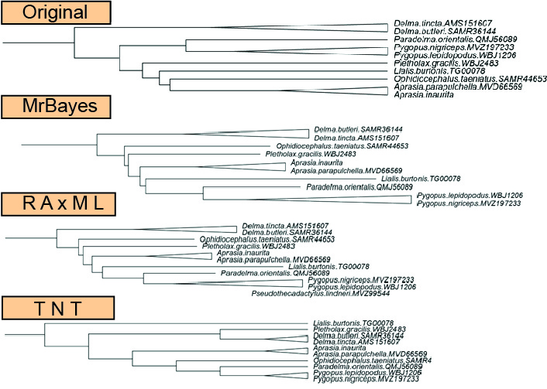

Figure 6. Comparison of the four topologies of Pygopodidae.

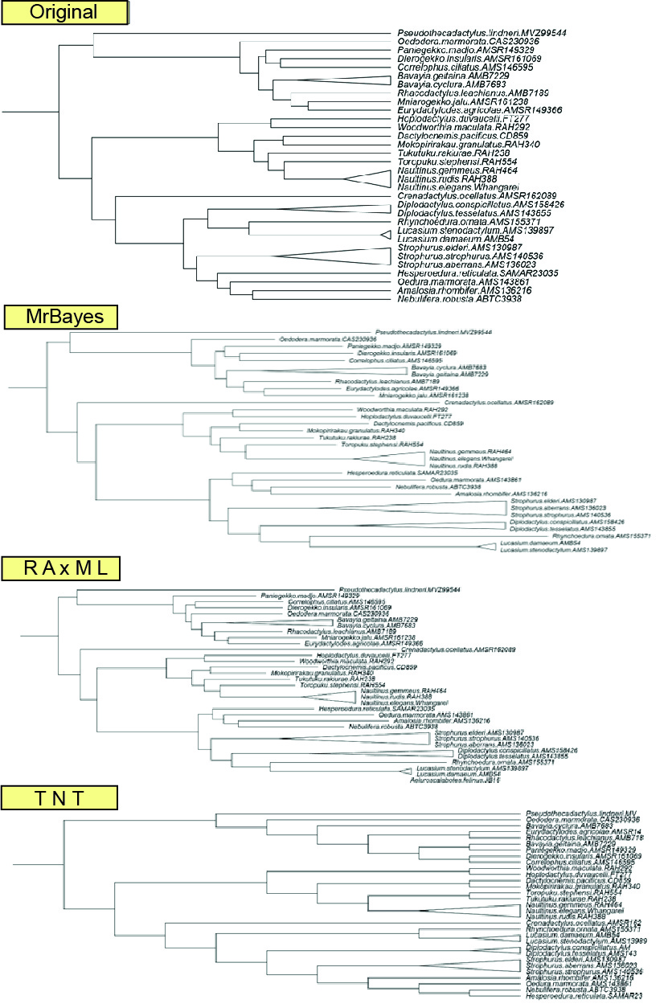

Figure 7. Comparison of the four topologies of Diplodactylidae.

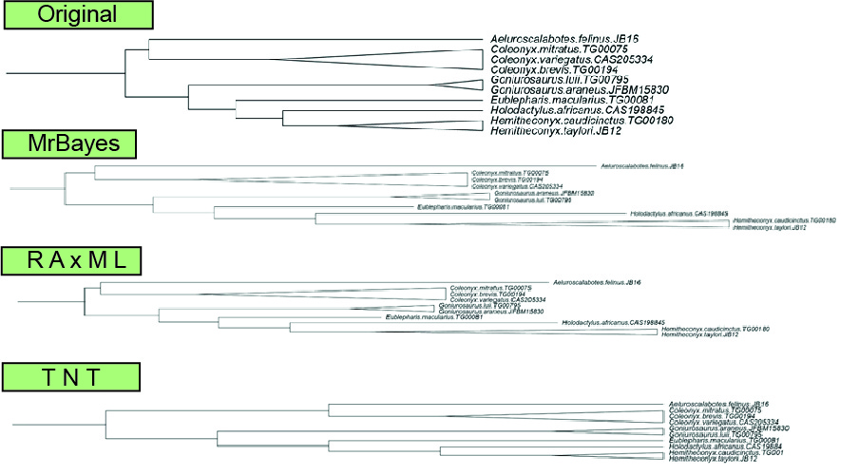

Figure 8. Comparison of the four topologies of Eublepharidae.

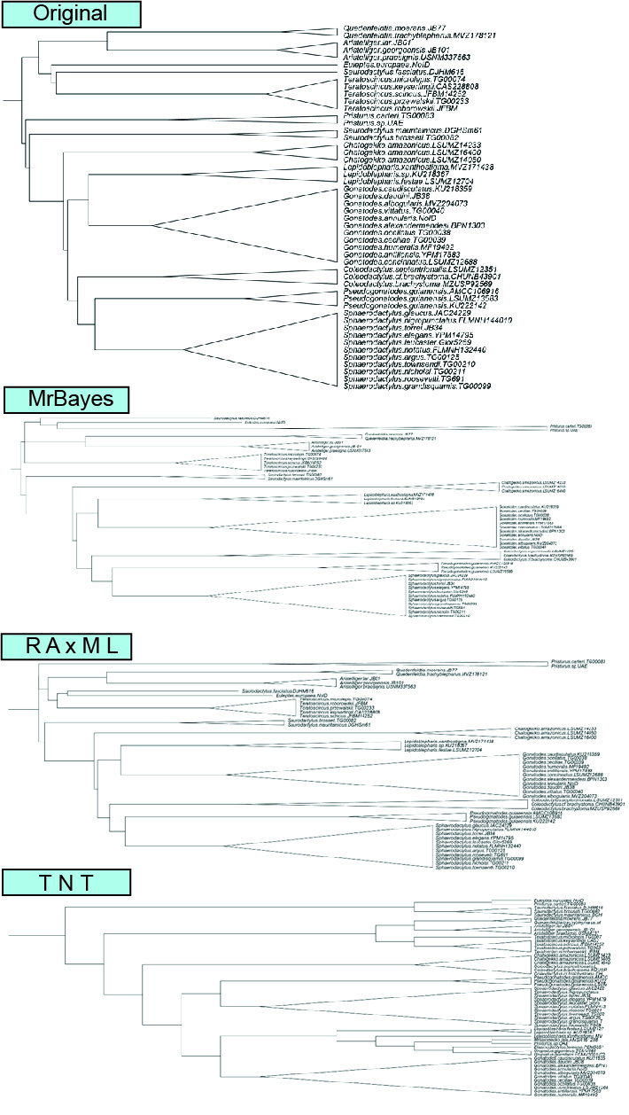

Figure 9. Comparison of the four topologies of Sphaerodactylidae.

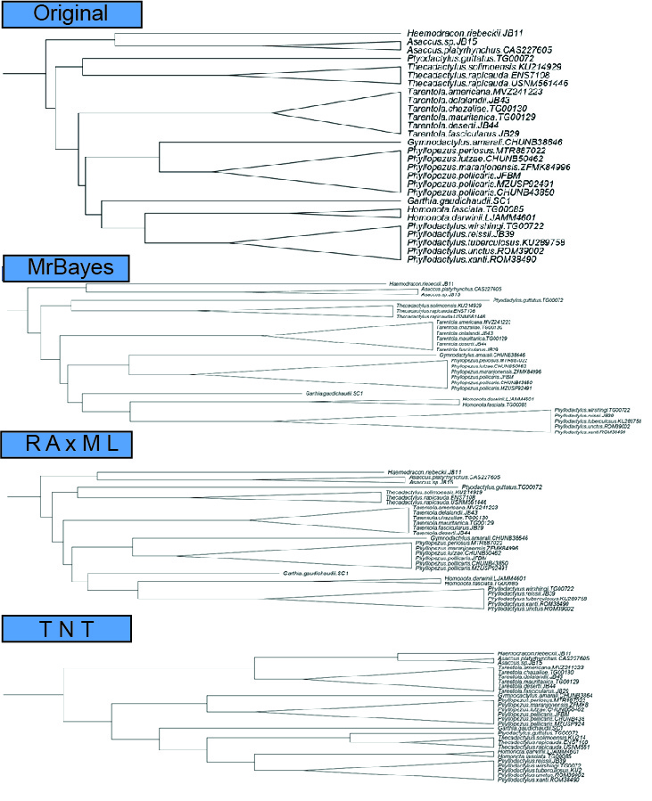

Figure 10. Comparison of the four topologies of Phyllodactylidae.

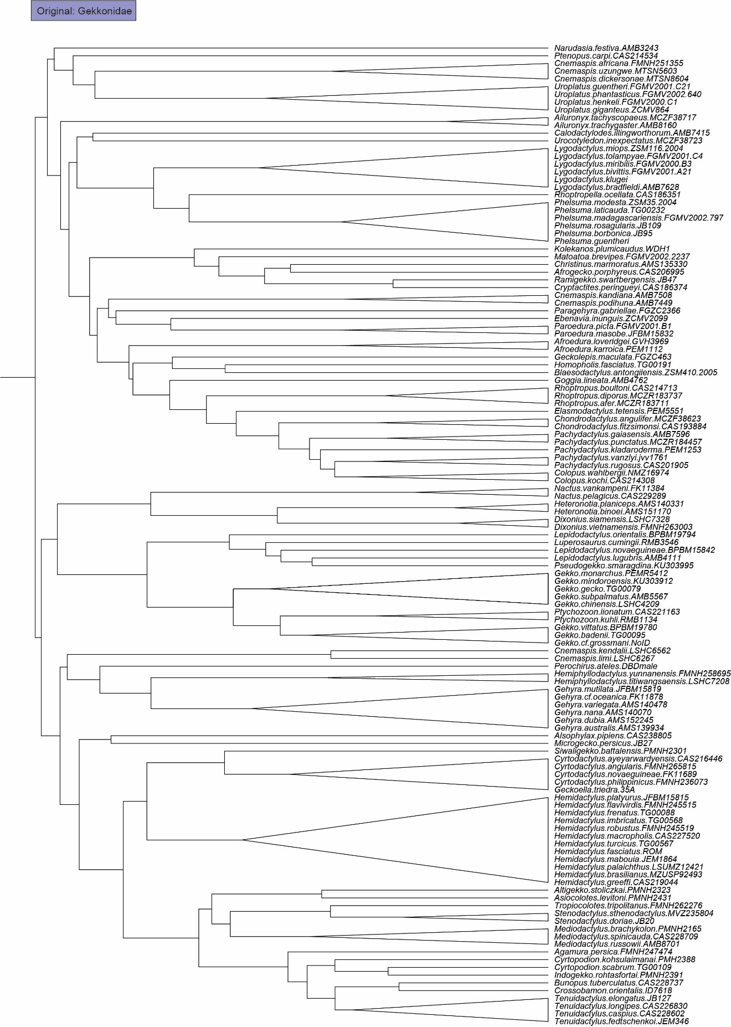

Figure 11. Comparison of the four topologies of Gekkonidae (1 of 4).

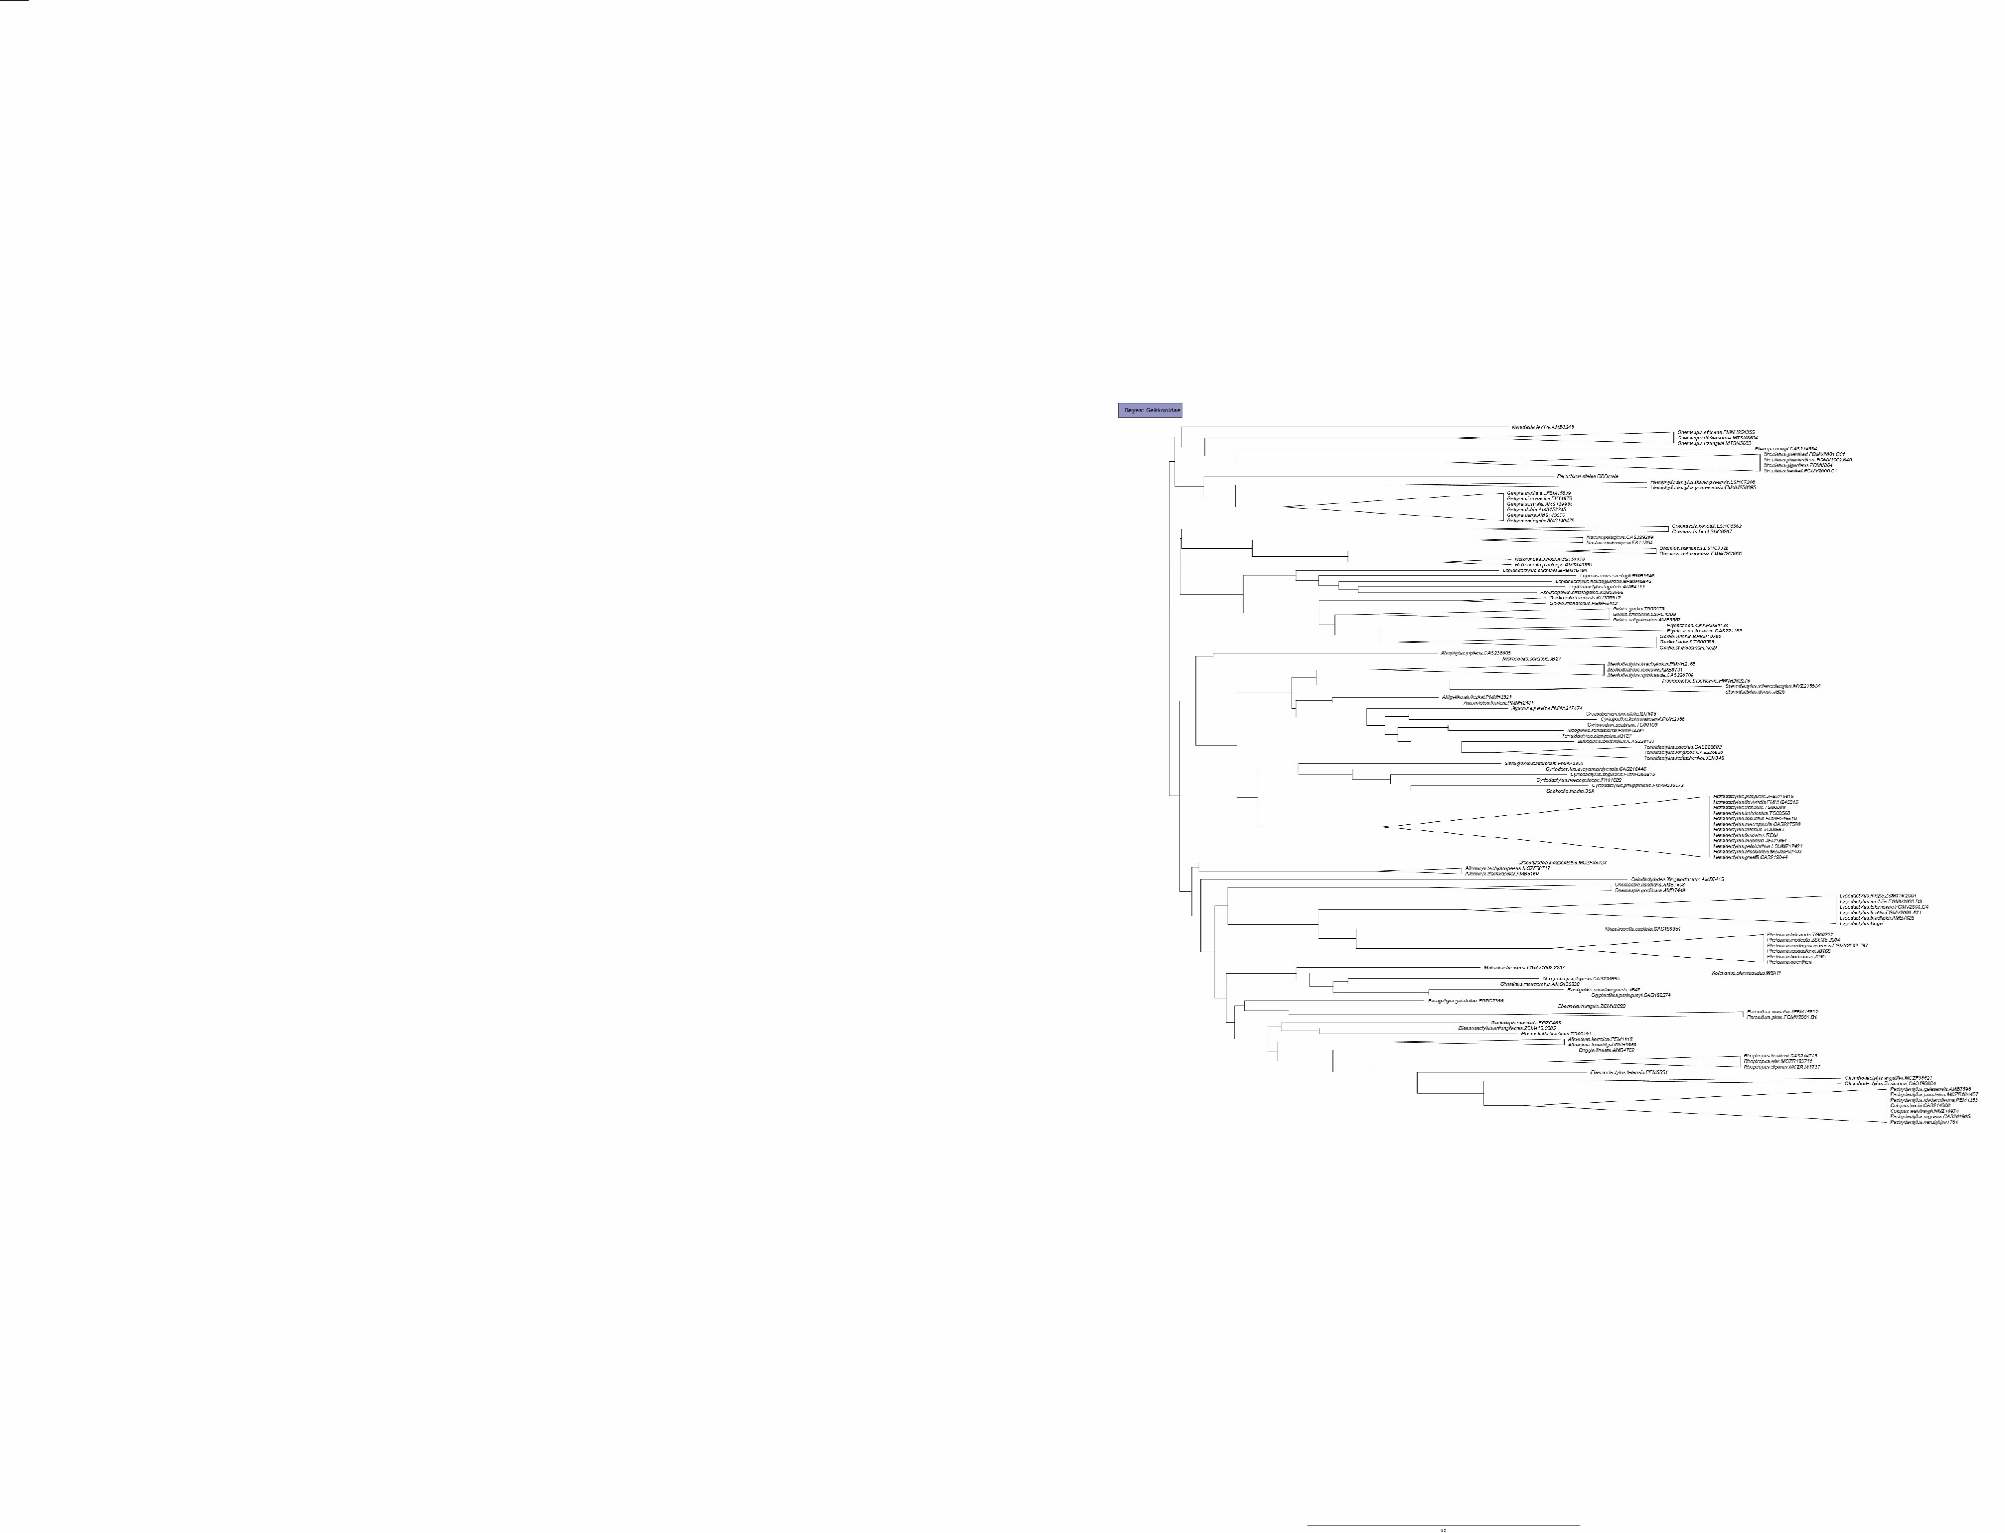

Figure 11. Comparison of the four topologies of Gekkonidae (2 of 4).

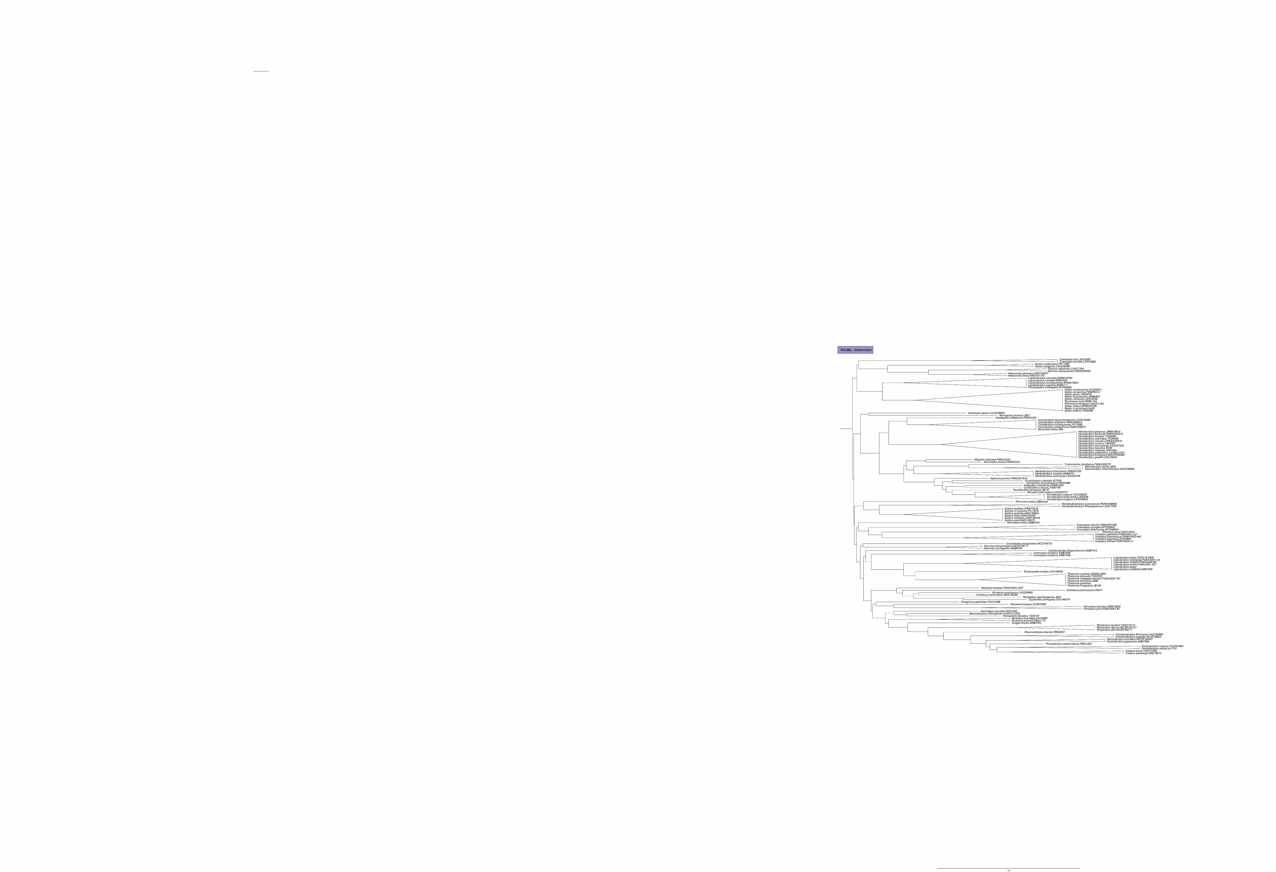

Figure 11. Comparison of the four topologies of Gekkonidae (3 of 4).

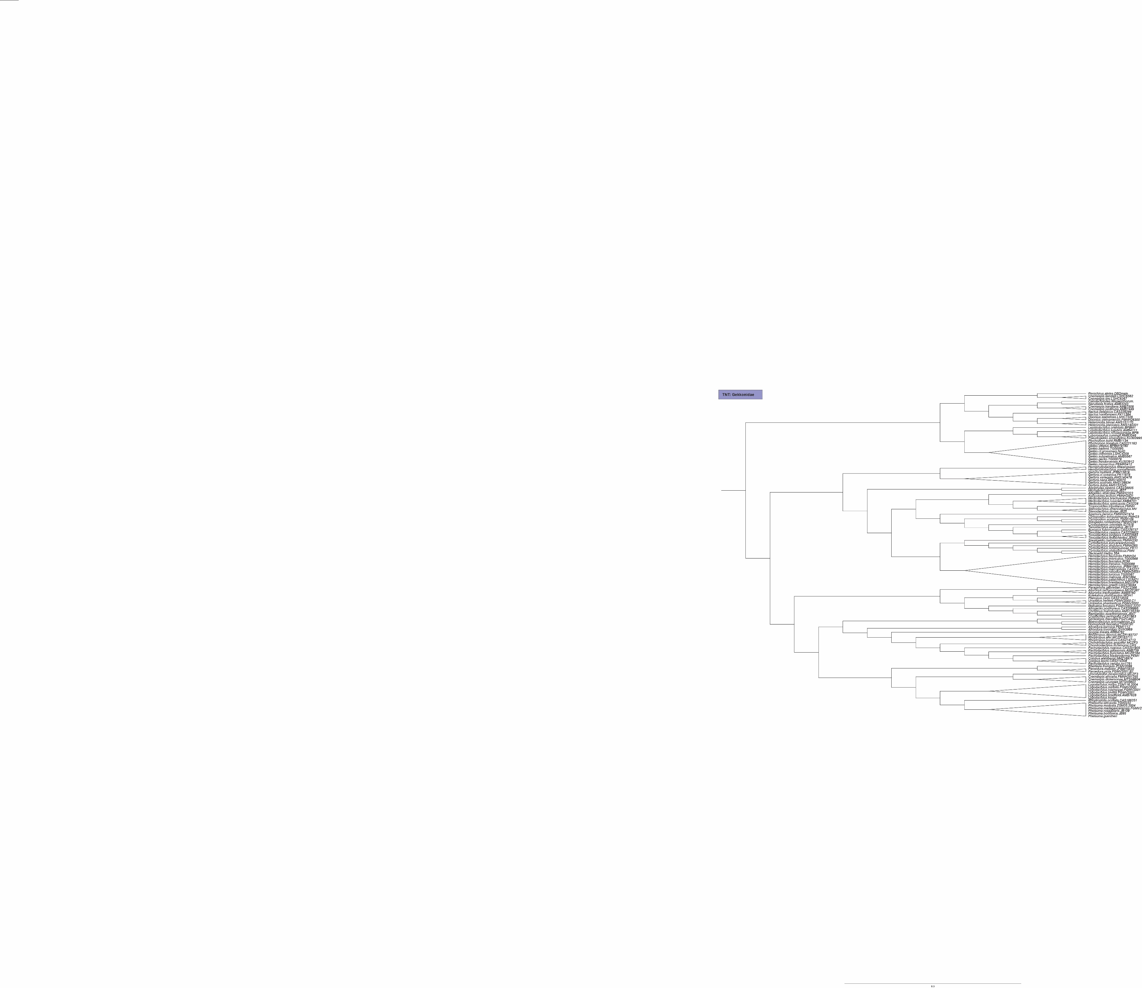

Figure 11. Comparison of the four topologies of Gekkonidae (4 of 4).